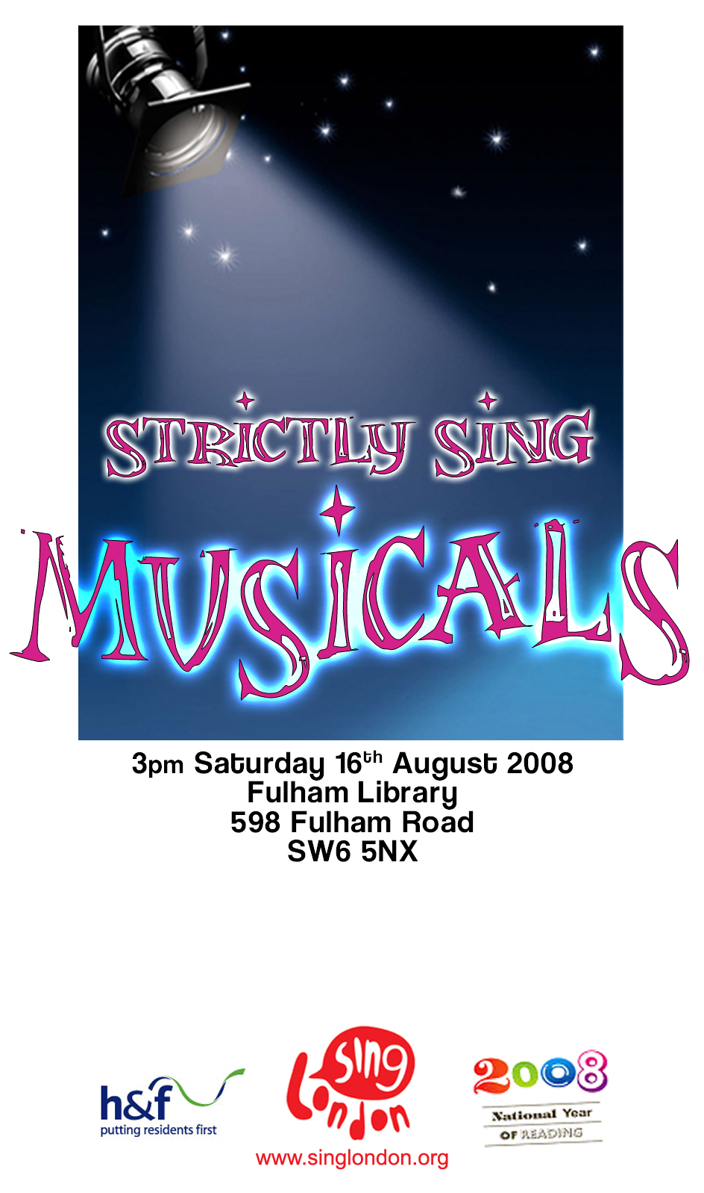
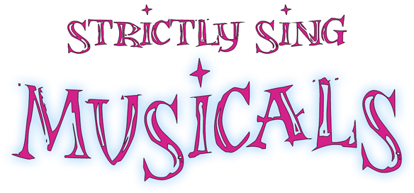

- All That Jazz (Chicago)
- Circle Of Life (The Lion King)
- Consider Yourself (Oliver)
- Day By Day (Godspell)
- Fame
- (I Wonder Why?) You're Just In Love (Call Me Madam)
- If I Were A Rich Man (Fiddler On The Roof)
- Johnny One Note (Babes In Arms)
- Guys and Dolls
- Mamma Mia
- One (A Chorus Line)
- Rhythm Of Life (Sweet Charity)
- Summer Nights (Grease)
- The Trolley Song (Meet Me In St. Louis)
- Tomorrow (Annie)

- All That Jazz
Come on babe, why don’t we paint the town?
And all that jazz
I’m gonna rouge my knees and roll my stockings down
And all that jazz
Start the car, I know a whoopee spot
Where the gin is cold, but the piano’s hot
It’s just a noisy hall where there’s a nightly brawl
And all... that... jazz

Slick your hair, and wear your buckle shoes
And all that jazz
I hear that Father Dipp is gonna blow the blues
And all that jazz
Hold on hun, we’re gonna bunny hug
I bought some aspirin, down at United Drug
In case we shake apart, and want a brand new start
To do... that... jazz

Oh, you’re gonna see your sheba shimmy shake
And all that jazz
Oh, she’s gonna shimmy till her garters break
And all that jazz
Show her where to park her girdle
Oh, her mother’s blood’ll curdle
Did she hear, her baby's queer
For all... that... jazz!

Oh, you’re gonna see your sheba shimmy shake
And all that jazz
Oh, she’s gonna shimmy till her garters break
And all that jazz
Show her where to park her girdle
Oh, her mother’s blood’ll curdle *
Did she hear, her baby's queer*
For all... that... jazz!
X 2
Find a flask, we’re playing fast and loose
And all that jazz
Right up here is where I store the juice
And all that jazz
Come on babe, we’re gonna brush the sky
I betcha lucky Lindy
Never flew so high
Cause in the stratosphere
How could he lend an ear
To all... that... jazz?

No, I’m no one’s wife
But, oh I love my life
And all... that... jazz!!

That jazz!
- Circle Of Life

Nants ingonyama bagithi Baba [Here comes a lion, Father]
Sithi uhm ingonyama [Oh yes, it's a lion]

Nants ingonyama bagithi baba
Sithi uhhmm ingonyama
Ingonyama

Siyo Nqoba [We're going to conquer]
Ingonyama
Ingonyama nengw' enamabala [A lion and a leopard come to this open place]

[Chant repeats]

From the day we arrive on the planet
And blinking, step into the sun
There's more to see than can ever be seen
More to do than can ever be done
There's far too much to take in here
More to find than can ever be found
But the sun rolling high through the sapphire sky
Keeps great and small on the endless round

It's the Circle of Life
And it moves us all
Through despair and hope
Through faith and love
Till we find our place
On the path unwinding
In the Circle
The Circle of Life

It's the Circle of Life
And it moves us all
Through despair and hope
Through faith and love
Till we find our place
On the path unwinding
In the Circle
The Circle of Life

- Consider Yourself

Consider yourself at home
Consider yourself one of the family
We've taken to you so strong
It's clear we're going to get along
Consider yourself well in
Consider yourself part of the furniture
There isn't a lot to spare
Who cares? What ever we've got we share!

If it should chance to be we should see some harder days
Empty larder days, why grouse?
Always a chance we'll meet somebody to foot the bill
Then the drinks are on the house!
Consider yourself our mate
We don't want to have no fuss,
For after some consideration, we can state
Consider yourself one of us!

Consider yourself at home
Consider yourself one of the family
We've taken to you so strong
It's clear we're going to get along
Consider yourself well in
Consider yourself part of the furniture
There isn't a lot to spare
Who cares? What ever we've got we share!

Nobody tries to be lah-di-dah or uppity
There's a cup o' tea for all
Only it's wise to be handy wiv a rolling pin
When the landlord comes to call

Consider yourself our mate
We don't want to have no fuss
For after some consideration we can state
Consider yourself
One of us

For after some consideration we can state
Consider yourself
One of us!

- Day By Day

Day by day
Day by day
Oh Dear Lord
Three things I pray
To see thee more clearly
Love thee more dearly
Follow thee more nearly
Day by day

- Fame

Baby look at me and tell me what you see
You ain't seen the best of me yet,
Give me time I'll make you forget the rest
I got more in me – and you can set it free
I can catch the moon in my hands, don't you know who I am,
Remember my name –
Fame
I'm gonna live forever, I'm gonna learn how to fly, high
I feel it coming together, people will see me and cry
Fame
I'm gonna make it to heaven, light up the sky like a flame
Fame
I'm gonna live forever, baby remember my name

Remember Remember Remember Remember
Remember Remember Remember Remember

Baby hold me tight ‘cause you can make it right
You can shoot me straight to the top,
Give me love and take all I've got to give
Baby I'll be tough - too much is not enough
I can ride your heart ‘til it breaks,
Ooh I got what it takes
Fame
I'm gonna live forever, I'm gonna learn how to fly, high
I feel it coming together, people will see me and cry
Fame
I'm gonna make it to heaven, light up the sky like a flame
Fame
I'm gonna live forever, baby remember my name
Fame
- (I Wonder Why?) You're Just In Love

(Kenneth:)
I hear singing and there's no one there
I smell blossoms and the trees are bare
All day long I seem to walk on air
I wonder why?
I wonder why?
I keep tossing in my sleep at night
And what's more I've lost my appetite
Stars that used to twinkle in the skies
Are twinkling in my eyes
I wonder why?

(Sally:)
You don't need analyzing
It is not so surprising
That you feel very strange but nice
Your heart goes pitter patter
I know just what's the matter
Because I've been there once or twice
Put your head on my shoulder
You need someone who's older
A rubdown with a velvet glove
There is nothing you can take
To relieve that pleasant ache
You're not sick
You're just in love

- If I Were A Rich Man

If I were a rich man
Daidle deedle daidle digguh digguh deedle daidle dum
All day long I'd biddy biddy bum, if I were a wealthy man
I wouldn't have to work hard
Daidle deedle daidle digguh digguh deedle daidle dum
If I were a biddy biddy rich, digguh digguh deedle daidle man

I'd build a big tall house with rooms by the dozen
Right in the middle of the town
A fine tin roof with real wooden floors below
There would be one long staircase just going up
And one even longer coming down,
And one more leading nowhere, just for show

If I were a rich man
Daidle deedle daidle digguh digguh deedle daidle dum
All day long I'd biddy biddy bum, if I were a wealthy man
I wouldn't have to work hard
Daidle deedle daidle digguh digguh deedle daidle dum
If I were a biddy biddy rich, digguh digguh deedle daidle man

I'd fill my yard with chicks and turkeys and geese and ducks
For the town to see and hear
And each loud "cheep" and "squawk" and "honk" and "quack"
Would land like a trumpet on the ear
As if to say "Here lives a wealthy man"

If I were a rich man
Daidle deedle daidle digguh digguh deedle daidle dum
All day long I'd biddy biddy bum, if I were a wealthy man
I wouldn't have to work hard
Daidle deedle daidle digguh digguh deedle daidle dum
Lord who made the lion and the lamb –
You decreed I should be what I am
Would it spoil some vast eternal plan
If I were a wealthy man?

- Johnny One Note

Johnny could only sing one note and the note he sings was this -
Ah!

Poor Johnny One Note sang out with gusto
And just overlorded the place
Poor Johnny One Note yelled willy nilly
Until he was blue in the face
For holding one note was his ace

Couldn’t hear the brass
Couldn’t hear the drum
He was in a class
By himself, by gum!

Poor Johnny One Note got in Aida,
Indeed a great chance to be brave
He took his one note, howled like the North Wind
Brought forth wind that made critics rave,
While Verdi turned round in his grave!

Couldn’t hear the flute
Or the big trombone
Ev’ry one was mute
Johnny stood alone

Cats and dogs stopped yapping
Lions in the zoo, all were jealous of Johnny's big trill
Thunder claps stopped clapping, traffic ceased its roar,
And they tell us Niagara stood still
He stopped the train whistles, boat whistles,
Steam whistles, cop whistles,
All whistles bowed to his skill
Ah!

Sing Johnny One Note, sing out with gusto
And just overlord all the crowd
So sing Johnny One Note out loud!!
Sing Johnny One Note
Sing Johnny One Note out loud!
- Guys and Dolls

When you see a guy reach for stars in the sky
You can bet that he's doing it for some doll
When you spot a John waiting out in the rain
Chances are he's insane as only a John can be for a Jane
When you meet a gent paying all kinds of rent
For a flat that could flatten the Taj Mahal
Call it sad, call it funny
But it's better than even money
That the guy's only doing it for some doll

When you see a Joe saving half of his dough
You can bet there'll be mink in it for some doll
When a bum buys wine like a bum can't afford
It's a cinch that the bum is under the thumb of some little broad
When you meet a mug lately out of the jug
And he's still lifting platinum folderol
Call it hell, call it heaven
But it's probable twelve to seven
That the guy's only doing it for some doll

When you see a sport and his cash has run short
Make a bet that he's banking it with some doll
When a guy wears tails with the front gleaming white
Who the hell do you think he's tickling pink on Saturday night?
When a lazy slob takes a goody steady job,
And he smells from vitalis and barbasol
Call it dumb, call it clever
Ah, but you can get odds forever
That the guy's only doing it for some doll
Some doll, some doll
The guy's only doing it for some doll

- Mamma Mia

I've been cheated by you since I don't know when
So I made up my mind, it must come to an end
Look at me now, will I ever learn?
I don't know how but I suddenly lose control
There's a fire within my soul
Just one look and I can hear a bell ring
One more look and I forget everything, w-o-o-o-oh

Mamma mia, here I go again
My my, how can I resist you?
Mamma mia, does it show again?
My my, just how much I've missed you
Yes, I've been brokenhearted
Blue since the day we parted
Why, why did I ever let you go?
Mamma mia, now I really know,
My my, I could never let you go.

I've been angry and sad about things that you do
I can't count all the times that I've told you we're through
And when you go, when you slam the door
I think you know that you won't be away too long
You know that I'm not that strong.
Just one look and I can hear a bell ring
One more look and I forget everything, w-o-o-o-oh

Mamma mia, here I go again
My my, how can I resist you?
Mamma mia, does it show again?
My my, just how much I've missed you
Yes, I've been brokenhearted
Blue since the day we parted
Why, why did I ever let you go?
Mamma mia, even if I say
Bye bye, leave me now or never
Mamma mia, it's a game we play
Bye bye doesn't mean forever

Mamma mia, here I go again
My my, how can I resist you?
Mamma mia, does it show again?
My my, just how much I've missed you
Yes, I've been brokenhearted
Blue since the day we parted
Why, why did I ever let you go
Mamma mia, now I really know
My my, I could never let you go
- One

Blokes:
One singular sensation, every little step she takes
One thrilling combination, every move that she makes
One smile and suddenly nobody else will do
You know you'll never be lonely with you-know-who

One moment in her presence and you can forget the rest
For the girl is second best to none, son
Oooh! Sigh! Give her your attention
Do I really have to mention she's the one

Girls:
One singular sensation, every little step she takes
One thrilling combination, every move that she makes
One smile and suddenly nobody else will do
You know you'll never be lonely with you-know-who

One moment in her presence and you can forget the rest
For the girl is second best to none, son
Oooh! Sigh! Give her your attention
Do I really have to mention she's the one

She walks into a room and you know she's uncommonly rare,
Very unique, peripatetic, poetic and chic
She walks into a room and you know from her
Maddening poise, effortless whirl, she's the special girl strolling
Can't help all of her qualities extolling
Loaded with charisma is ma jauntily sauntering, ambling shambler
She walks into a room and you know you must
Shuffle along, join the parade
She's the quintessence of making the grade
This is whatcha call trav'ling!
Oh strut your stuff!
Can't get enough of her! Love her!
I’m a son of a gun, she is one of a kind

- Rhythm Of Life

Daddy started out in San Francisco, tootin' on his trumpet loud and mean,
Suddenly a voice said, "Go forth Daddy,
Spread the picture on a wider screen"
And the voice said, "Brother, there's a million pigeons
Waiting to be hooked on new religions
Hit the road, Daddy, leave your common-law wife,
Spread the religion of The Rhythm Of Life"
And The Rhythm Of Life is a powerful beat,
Puts a tingle in your fingers and a tingle in your feet,
Rhythm in your bedroom, rhythm in the street,
Yes, The Rhythm Of Life is a powerful beat,
To feel The Rhythm Of Life, to feel the powerful beat,
To feel the tingle in your fingers, to feel the tingle in your feet,
Daddy go, go go go
Daddy, spread the gospel in Milwaukee,
Took his walkie talkie to Rocky Ridge,
Blew his way to Canton, then to Scranton,
‘Til he landed under the Manhattan Bridge
Daddy was the new sensation, got himself a congregation,
Built up quite an operation down below
With the pie-eyed piper blowing, while the muscatel was flowing,
All the cats were go, go, go-ing down below
Daddy was the new sensation, got himself a congregation,
Built up quite an operation down below
With the pie-eyed piper blowing, while the muscatel was flowing,
All the cats were go, go, go-ing down below
Flip your wings and fly to Daddy, flip your wings and fly to Daddy,
Flip your wings and fly to Daddy, fly, fly, fly to Daddy,
Take a dive and swim to Daddy, take a dive and swim to Daddy,
Take a dive and swim to Daddy, swim, swim, swim to Daddy
Hit the floor and crawl to Daddy, hit the floor and crawl to Daddy,
Hit the floor and crawl to Daddy, crawl, crawl, crawl to Daddy,
And The Rhythm Of Life is a powerful beat,
Puts a tingle in your fingers and a tingle in your feet,
Rhythm in your bedroom, rhythm in the street,
Yes, The Rhythm Of Life is a powerful beat,
To feel The Rhythm Of Life, to feel the powerful beat,
To feel the tingle in your fingers, to feel the tingle in your feet,
To feel The Rhythm Of Life, to feel the powerful beat,
To feel the tingle in your fingers, to feel the tingle in your feet,
Flip your wings and fly to Daddy,
Take a dive and swim to Daddy,
Hit the floor and crawl to Daddy,
Daddy we got The Rhythm Of Life,
Of life, of life, of life! Yeah! Yeah! Yeah! Man!
- Summer Nights
[Danny] Summer lovin' had me a blast
[Sandy] Summer lovin' happened so fast
[Danny] I met a girl crazy for me
[Sandy] Met a boy cute as can be
[Both] Summer days driftin' away, to uh-oh those summer nights
[Everyone] Uh well-a well-a well-a huh
[Thunderbirds] Tell me more, tell me more
[Doody] Did you get very far?
[Pink Ladies] Tell me more, tell me more
[Marty] Like does he have a car?
[Everyone] Uh-huh uh-huh uh-huh uh-huh
[Danny] She swam by me, she got a cramp
[Sandy] He ran by me, got my suit damp
[Danny] I saved her life, she nearly drowned
[Sandy] He showed off, splashing around
[Both] Summer sun, something's begun, but uh-oh those summer nights
[Everyone] Uh well-a well-a well-a huh
[Pink Ladies] Tell me more, tell me more
[Frenchy] Was it love at first sight?
[Thunderbirds] Tell me more, tell me more
[Kenickie] Did she put up a fight?
[Everyone] Uh-huh-uh-huh-uh-huh-uh-huh
[Danny] Took her bowling in the arcade
[Sandy] We went strolling, drank lemonade
[Danny] We made out under the dock
[Sandy] We stayed out 'till ten o'clock
[Both] Summer fling, don't mean a thing, but uh-oh those summer nights
[Everyone] Uh well-a well-a well-a huh
[Thunderbirds] Tell me more, tell me more
[Putzie] But you don't gotta brag
[Pink Ladies] Tell me more, tell me more
[Rizzo] ‘Cos he sounds like a drag
[Everyone] Shoo-bop bop, shoo-bop bop, shoo-bop bop, shoo-bop bop, Shoo-bop bop, shoo-bop bop, shoo-bop bop, YEH
[Sandy] He got friendly, holding my hand
[Danny] Well she got friendly down in the sand
[Sandy] He was sweet, just turned eighteen
[Danny] Well she was good, you know what I mean
[Everyone] Woah!
[Both] Summer heat, boy and girl meet, but uh-oh those summer nights
[Everyone] Woo, woo, woo
[Pink Ladies] Tell me more, tell me more
[Jan] How much dough did he spend?
[Thunderbirds] Tell me more, tell me more
[Sonny] Could she get me a friend?
[Sandy] It turned colder - that's where it ends
[Danny] So I told her we'd still be friends
[Sandy] Then we made our true love vow
[Danny] Wonder what she's doing now
[Both] Summer dreams ripped at the seams, bu-ut oh,
Those su-ummer nights....
[Everyone] Tell me more, tell me more!
- The Trolley Song

With my high starched collar and my high top shoes
And my hair piled high upon my head
I went to lose a jolly hour on the trolley and lost my heart instead
With his light brown derby and his bright green tie,
He was quite the handsomest of men
I started to yen, so I counted to ten, then I counted to ten again

Clang, clang, clang went the trolley,
Ding, ding, ding went the bell
Zing, zing, zing went my heart strings,
From the moment I saw him I fell
Chug, chug, chug went the motor,
Bump, bump bump went the brake,
Thump, thump, thump went my heart strings,
When he smiled, I could feel the car shake

He tipped his hat and took a seat
He said he hoped he hadn't stepped upon my feet
He asked my name I held my breath
I couldn't speak because he scared me half to death

Buzz, buzz, buzz went the buzzer,
Plop, plop, plop went the wheels,
Stop, stop, stop went my heart strings
As he started to go, then I started to know how it feels
When the universe reels

The day was bright, the air was sweet
The smell of honeysuckle charmed you off your feet
You tried to sing, but couldn't squeak
In fact you loved him so you couldn't even speak

Buzz, buzz, buzz went the buzzer,
Plop, plop, plop went the wheels
Stop, stop, stop went my heart strings
As he started to leave I took hold of his sleeve
With my hand, and as if it were planned,
He stayed on with me,
And it was grand just to stand with his hand holding mine
To the end of the line

- Tomorrow

The sun'll come out tomorrow
Bet your bottom dollar that tomorrow
There'll be sun
Just thinkin' about tomorrow
Clears away the cobwebs and the sorrow
'Til there's none

When I'm stuck with a day that's grey and lonely
I just stick out my chin and grin and say - oh
The sun'll come out tomorrow
So ya gotta hang on ‘til tomorrow - come what may
Tomorrow! Tomorrow! I love ya tomorrow!
You're always a day away

When I'm stuck with a day that's grey and lonely
I just stick out my chin and grin and say - oh
The sun'll come out tomorrow
So ya gotta hang on ‘til tomorrow - come what may
Tomorrow! Tomorrow! I love ya tomorrow!
You're always a day away
Tomorrow! Tomorrow! I love ya tomorrow!
You're always a day away

